Question Paper Set A13
AI-Assisted Coding Exam — Python (1 hour)
- You may either (a) write the exact prompt to have your AI assistant generate code, or (b) write the code yourself. If you use AI, submit the prompt and the final code you executed.
- Use VS Code Copilot / Gemini / CursorAI. Credit your prompts.
- Prefer Python standard library; write clear, tested, well-documented code.
- Each subgroup (A–O) has two tasks. Attempt all. Medium complexity, use-case based.
- Syllabus pillars:
A–C: AI completion (classes, loops, conditionals)
D–E: Debugging with AI
F–G: TDD with AI
H–I: Documentation & Code Review
J–K: Code Quality & Performance
L–M: Files/CSV & Regex
N–O: Algorithms & Data Structures
Deliverables for each question
1) If using AI: the exact prompt you issued. If manual: note 'manual' and a brief design reason.
2) solution.py
3) tests.py (unittest/pytest; write tests first for TDD items)
4) Docstrings & inline comments (AI-assisted allowed)
5) Short README.md (approach, assumptions, complexity, run tests)
6) For debugging/refactor: brief before/after note
Question Paper Set A13

AI-Assisted Coding Exam — Python (1 hour)
- You may either (a) write the exact prompt to have your AI assistant generate code, or (b) write the code yourself. If you use AI, submit the prompt and the final code you executed.
- Use VS Code Copilot / Gemini / CursorAI. Credit your prompts.
- Prefer Python standard library; write clear, tested, well-documented code.
- Each subgroup (A–O) has two tasks. Attempt all. Medium complexity, use-case based.

Subgroup C

C.1 — [S13C1] Debug de-duplication (case-insensitive)
Scenario (agritech):
Context:
Customer contact lists in the agritech CRM contain duplicates differing only by case (e.g., 'A@x.com' vs 'a@x.com').

Your Task:
Write a function that returns the first occurrence of each email (case-insensitive) while preserving the original order.

Data & Edge Cases:
Input: list of emails. Normalize for comparison using lowercase; keep the original cased value for output.

AI Assistance Expectation:
Use AI to spot the bug (reinitializing `seen` in a loop) and propose a corrected, stable algorithm.

Constraints & Notes:
Include unit tests covering: ['A@x.com','a@x.com','B@y.com'] -> ['A@x.com','B@y.com']
Sample Input
['A@x.com', 'a@x.com', 'B@y.com']
Sample Output
['A@x.com', 'B@y.com']
Acceptance Criteria: Preserves first occurrence order; case-insensitive matching

Prompt:
Write a Python function that deduplicates a list of email addresses using case-insensitive comparison while maintaining the original casing and order of the first occurrence of each unique email. The function should handle mixed-case duplicates like "Alice@example.com" and "alice@example.com" by keeping only the first one.
Code :
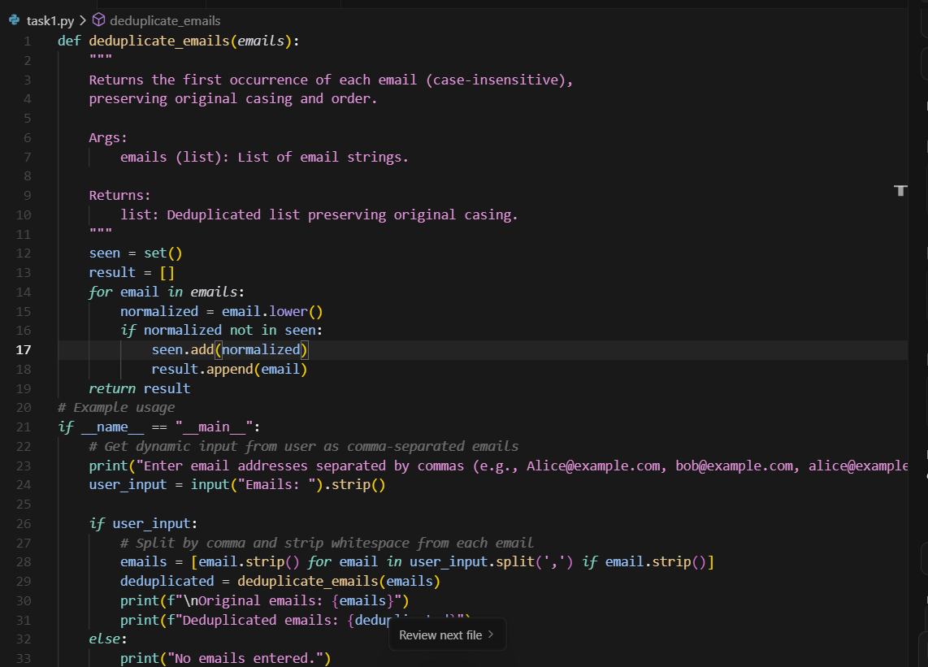
Output :
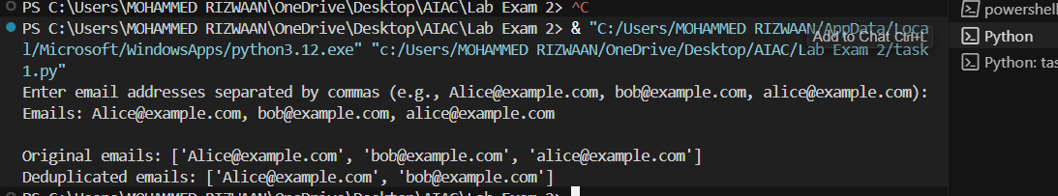

C.2 — [S13C2] TDD: slugify titles
Scenario (agritech):
Context:
Content titles in the agritech CMS must become SEO-friendly slugs for URLs.

Your Task:
Design tests first for slugify(text) then implement: lowercase, remove non-alnum except hyphen, spaces->hyphen, collapse multiple hyphens, trim hyphens.

Data & Edge Cases:
Test punctuation, multiple spaces, and boundary hyphens.

AI Assistance Expectation:
Use AI to generate parameterized tests (pytest) and then implement a regex-based slugify.

Constraints & Notes:
Return correct slugs for provided samples.
Sample Input
['Hello World!', 'AI & You', 'Set13-C2']
Sample Output
['hello-world', 'ai-you', 'set13-C2']
Acceptance Criteria: All tests pass; edge cases covered

------------------------------------------------------------

Prompt:
Write a Python function that transforms any text string into a clean URL slug by: 1) converting to lowercase, 2) replacing whitespace with single hyphens, 3) removing all non-alphanumeric characters except hyphens, 4) collapsing multiple hyphens into single ones, and 5) trimming leading/trailing hyphens.
Code:
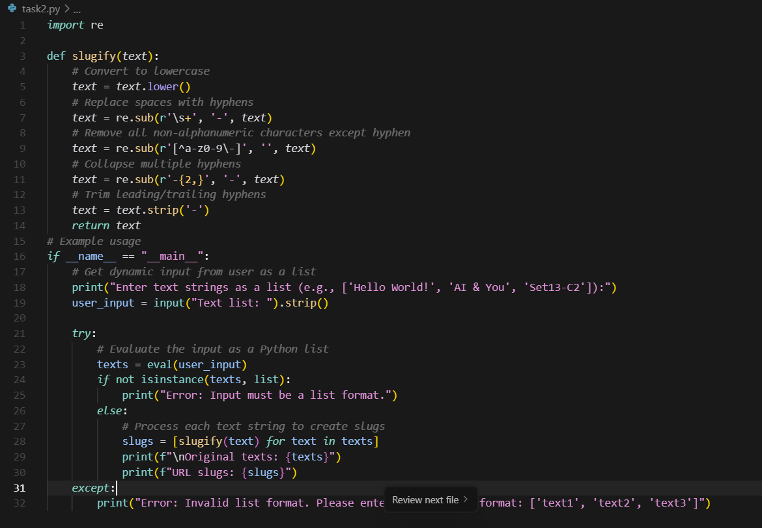
Output:
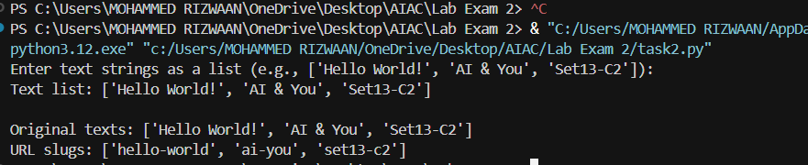
Generation of test cases :
